**AGRO AGENCY**

# A MINI-PROJECT REPORT

Submitted to

# COMPUTER SCIENCE AND ENGINEERING DEPARTMENT

Submitted by

**A.Akash Sumanth Kumar**

**(19KN1A0506)**

Under the esteemed guidance of

## Mr.P.Raghuveer

## Assoc Professor, CSE Department



**DEPARTMENT OF COMPUTER SCIENCE AND ENGINEERING**

**NRI INSTITUTE OF TECHNOLOGY**

## (Approved by AICTE, Permanently Affiliated to JNTUK, Kakinada) (Accredited by NAAC with ‘A’ Grade, ISO 9001 : 2015 Certified) Pothavarappadu (V), Agiripalli (M), Krishna Dist, PIN: 521212, A.P India.

**2020-2021**

**NRI INSTITUTE OF TECHNOLOGY**

## (Approved by AICTE, Permanently Affiliated to JNTUK, Kakinada) (Accredited by NAAC with ‘A’ Grade, ISO 9001 : 2015 Certified)

**Pothavarappadu (V), Agiripalli (M), Krishna Dist, PIN: 521212, A.P, India.**

Certificate

This is to certify that the Mini-Project entitle **“AGRO AGENCY”** is a bonafide work carried out by **A.Akash Sumanth Kumar (19KN1A0506)** in partial fulfillment for the award of degree of Bachelor of Technology in **Computer Science & Engineering** of **NRI Institute of Technology** during the year 2020-2021.

|  |  |  |
| --- | --- | --- |
| **Mr.P.Raghuveer** | **Dr Ch.Surya Kiran** | **Dr D.Suneetha** |
| **(Project Guide)** | **(Project Coordinator)** | **(HOD, CSE)** |

## ABSTRACT

India is an agricultural based country. The main livelihood of the majority population here is through farming who well in villages and feed the whole country. Food is one of the basic necessities of a human being, which is fulfilled by the framers. However, they fail to get proper price of the stock they sell in the market. Hence, they are deprived from getting profits for their stock. AGRO AGENCY helps them in getting proper price for their stock and even get profit for their efforts.

The main scenario of AGRO AGENCY is the project will declare the minimum and maximum value of the crop a daily update. When farmers register in the agency the agency will help in monitoring the crops throughout the season.So that the farmers will not get any loss.

The agro agency will also helps the crop progress.

## INDEX

1. Introduction 1
   1. Introduction to project 2
   2. Problem Definition 2
   3. Solution for Problem Definition 2
2. Literature Review 3-4
3. System Analysis 5
   1. Existing System 6
   2. Proposed System 6
   3. Analysis Model 6
   4. Modules 7
4. Feasibility study 8
   1. Technical Feasibility 9
   2. Economical Feasibility 10
   3. Operational Feasibility 10
5. Software Requirement Specification 12
   1. Introduction 13
   2. Functional Requirements 14
   3. Non-Functional Requirements 14
   4. Requirement Specification 15
      1. Software Requirements 15
      2. Hardware Requirements 15
6. System Design 16
   1. Introduction 17
   2. High level Design 17
   3. Low level Design 18
      1. Use case Diagram 19
      2. Sequence Diagram 20
      3. ER Diagram 21
      4. Class Diagram 22
      5. Data Flow Diagram (DFD) 23
7. Coding 24
   1. Sample Code 25
8. Testing 31
   1. Unit Testing 34
   2. Integration Testing 34
   3. Acceptance Testing 35
9. **Screenshots 36-43**

## Conclusion 44-45

1. **Future Enhancements 46-47**

## Bibliography 48-49

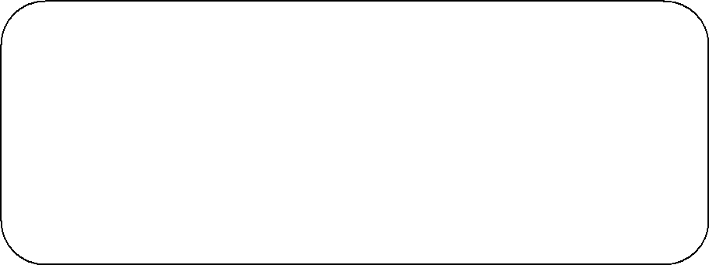

***CHAPTER-1***

***INTRODUCTION***

* 1. **INTRODUCTION**

There is no common definition of “organic” because different countries have different standard for products to be certified “organic”. In simplest words, organic foods are minimally processed to maintain the integrity of the food without artificial ingredients, preservatives or irradiation. Organic products are obtained by processes friendly to the environment, by cultivation techniques that consider both the attributes of the final product and the production methods.

## PROBLEM DEFINITION

Organic farmers who also farm on arable land very often use very simple and improper crop rotations with high share of cereal crops and low share of legumes.

## 1.3 SOLUTION FOR PROBLEM DEFINITION

I have to design a solution for the problem.

Here the measure can consist of producers cooperation, Central Institute for Supervising and Testing in Agriculture, standards and regulations revision, new plant-breeding companies government support, development of sample farms, organic farmers education, access to courses and reference material, specialisation of consultants for seed production, divided certification for organic and conventional farming, indirect grants for use/production seeds for organic farming and research. .



***CHAPTER-2 LITERATURE REVIEW***

# Literature review

It is atraditional marketing concept imparts that the products were made to be sold to the customers, whereas the modern marketing practices emphasize on identifying the needs of the customers and then starts the manufacturing process. However, the current marketing concepts extend towards satisfying the needs of the customers without causing any environmental degradation. Now-a-days customers are expected to minimize environmental degradation through their consumption habits..

***CHAPTER 3* *SYSTEM ANALYSIS***

## EXISTING SYSTEM

In the existing system we observe that user need to visit and fill a signup and login form. In the existing online system, there exists an admin who needs to collect the information from our website in different locations and needs to update constantly about the products.

## PROPOSED SYSTEM

 Over the past several years there has been considerable interest in expanding our faculty expertise, course offerings, research and outreach to include a dedicated focus on providing the knowledge and skills necessary for a growing workforce in organic production systems; with an emphasis on field-based experiential learning.

It will have the specific teaching, research, and outreach expertise in soil microbiology and/or agroecology. The new faculty position is essential for the establishment of a 22-unit certificate of special study in Organic Production Systems.

## ANALYSIS MODEL

The model that is basically being followed is the WATERFALL MODEL, which states that the phases are organized in a linear order. First of all the feasibility study is done.Once that part is over the requirement analysis and project planning begins. If system exists one and modification and addition of new module is needed, analysis of present system can be used as basic model.

The design starts after the requirement analysis is complete and the coding begins after the design is complete. Once the programming is completed, the testing is done. In this model the sequence of activities performed in a software development project are: Requirement Analysis, Project Planning, System design, Detail design, Coding, Unit testing, System integration & testing.

Here the linear ordering of these activities is critical. End of the phase and the output of one phase is the input of other phase. The output of each phase is to be consistent with the overall requirement of the system. Some of the qualities of spiral model are also incorporated like after the people concerned with the project review completion of each of the phase the work done.

WATER FALL MODEL was being chosen because all requirements were known beforehand and the objective of our software development is the computerization/automation of an already existing manual working system.

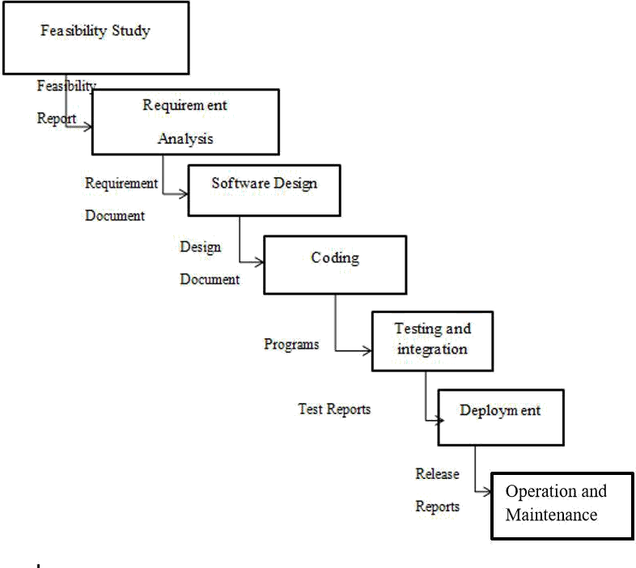

## Fig. Waterfall model (SDLC)

## MODULES

***User and Admin Registration***: User and the Admin both can register into this web application by providing basic information by filling the registration forms provided to them.

***User and Admin Login:*** User and the admin both can login to their accounts and can perform some actions like booking a product.

***Book a product:*** User can book a product in a desired products by providing information needed to book a organic product. And once he click on the book a item.

***User Information:*** website Admin can access the user information who booked a items in their website.

***CHAPTER 4 FEASIBILITY STUDY***

## 4.Feasibility Study

Feasibility Study is a high level capsule version of the entire process intended to answer a number of questions like: What is the problem? Is there any feasible solution to the given problem? Is the problem even worth solving? Feasibility study is conducted once the problem clearly understood. Feasibility study is necessary to determine that the proposed system is Feasible by considering the technical, Operational, and Economical factors. By having a detailed feasibility study the management will have a clear-cut view of the proposed system.

The following feasibilities are considered for the project in order to ensure that the project is variable and it does not have any major obstructions. Feasibility study encompasses the following things:

* Technical Feasibility.
* Economical Feasibility.
* Operational Feasibility.

In this phase, we study the feasibility of all proposed systems, and pick the best feasible solution for the problem. The feasibility is studied based on three main factors as follows.

## Technical Feasibility

In this step, we verify whether the proposed systems are technically feasible or not. i.e., all the technologies required to develop the system are available readily or not.

Technical Feasibility determines whether the organization has the technology and skills necessary to carry out the project and how this should be obtained. The system can be feasible because of the following grounds.

* All necessary technology exists to develop the system.
* This system is flexible and it can be expanded further.
* This system can give guarantee of accuracy, ease of use, and reliability.
* Our project is technically feasible because, all the technology needed for our project is readily available.

## Economical Feasibility

In this step, we verify which proposal is more economical. We compare the financial benefits of the new system with the investment. The new system is economically feasible only when the financial benefits are more than the investments and expenditure.

Economical Feasibility determines whether the project goal can be within the resource limits allocated to it or not. It must determine whether it is worthwhile to process with the entire project or whether the benefits obtained from the new system are not worth the costs. Financial benefits must be equal or exceed the costs. In this issue, we should consider:

* + The cost to conduct a full system investigation.
  + The cost of h/w and s/w for the class of application being considered.
  + The development tool.
  + The cost of maintenance etc.

Our project is economically feasible because the cost of development is very minimal when compared to financial benefits of the application.

## Operational Feasibility

In this step, we verify different operational factors of the proposed systems like manpower, time etc., whichever solution uses less operational resources, is the best operationally feasible solution. The solution should also be operationally possible to implement. Operational Feasibility determines if the proposed system satisfied user objectives could be fitted into the current system operation. The present system Smart Traffic Control can be justified as operationally feasible based on the following grounds.

* + The methods of processing and presentation are completely accepted by the clients since they can meet all user requirements.
  + The clients have been involved in the planning and development of the system.
  + The proposed system will not cause any problem under any circumstances.

Our project is operationally feasible because the time requirements and personnel requirements are satisfied. We are a team of four members and we worked on this project for three working months.

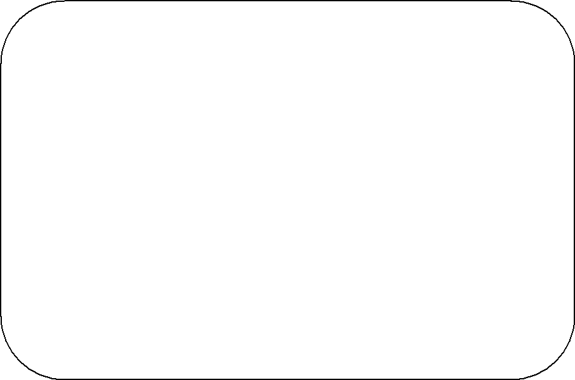

***CHAPTER-5 SYSTEM REQUIREMENT SPECIFICATION***

## Introduction

A Software Requirements specification (SRS) – a requirements specification for a software system- is a complete description of behaviour of a system to be developed. It includes a set of cases that describe all he interactions users will have with the software. In addition to use cases, the SRS also contains non-functional requirements. Non-functional requirements are requirements which impose constraints on the design or implementation (such as performance engineering requirements, quality standards, or design constraints).

## System Requirements Specification

It is a collection of information that embodies the requirements of a system. A business analyst, sometimes titled system analyst, is responsible for analyzing the business needs of their clients and stakeholders to help identify business problems and propose solutions. Projects are subject to three sorts of require elements.

* Business requirements describe in business terms what must be delivered or accomplished to provide value.
* Product requirements describe properties of a system or product (which could be one of several ways to accomplish a set of business requirements.)
* Process requirements describe activities performed by the developing organization. For instance, process requirements could specify methodologies that must be followed, and constraints that the organization must obey.

Product and process requirements are closely linked. Process requirements often specify the activities that will be performed to satisfy a product requirement. For example, a maximum development cost requirement (a process requirement) may be imposed to help achieve a maximum sales price requirement ( a product requirement) a requirement that the product be maintainable ( a product requirement) often is addressed by imposing requirements to follow particular development styles.

A system engineering, a requirement can be a description of what a system must do, referred to as Functional Requirement. This type of requirement specifies something that the delivered system must be able to do. Another type of requirement specifies something about the system itself, and how well it performs its functions. Such requirements are often called Non-functional requirements, or ‘Performance requirements’ or ‘Quality of service requirements’. Examples of such requirements include usability, availability, reliability, supportability, testability and maintainability.

A collection of requirements define the characteristics or features of the desired system. A ‘good’ list of requirements as far as possible avoids saying how the system should implement the requirements, leaving such decisions to the system designer. Specifying how the system should be implemented is called “implementation bias” or “solution engineering”. However, implementation constraints on the solution may validly be expressed by the future owner, for example for required interfaces to external systems; for inter operability with other systems; and for commonality with other owned products.

## Functional Requirements

The Functional Requirements Specification gives the operations and activities that a system must be able to perform. Functional requirements should include functions performed by specific screens, outlines of work-flows performed by the system, and other business or compliance requirements the system must meet. It also depends upon the type of software, expected users and the type of system where the software is used

* + user id is provided for the register users.
  + The system must only allow user with valid id and password to enter the system.
  + The system performs authorization process which decides what user level can acess to.
  + The user must be able to logout after they finished using system.

## Non-Functional Requirements

In systems engineering, a non-functional requirement is a requirement that specifies criteria that can be used to judge the operation of a system, rather than specific behaviours. They are contrasted with functional requirements that define specific behaviour or functions. The non- functional requirements can be considered as quality attributes of a system Performance.

EFFICIENCY REQUIREMENT 

When a library management system will be implemented librarian and user will easily access library as searching and book transaction will be very faster.

RELIABILITY REQUIREMENT:

The system should accurately performs member registration, member validation, report generation, book transaction and search.

USABILITY REQUIREMENT:

The system is designed for a user friendly environment so that student and staff of library can perform the various tasks easily and in an effective way.

# REQUIREMENT SPECIFICATION

## SOFTWARE REQUIREMENTS

Language using : HTML,PHP,CSS Software : Xampp

Operating system : windows 10

## HARDWARE REQUIREMENTS

system : Pentium IV 2.4GHz(minimum)

Hard disk : 1TB

RAM : 8GB

Processor : i5



***CHAPTER-6***

***SYSTEM DESIGN***

## INTRODUCTION

Systems design is the process of defining the architecture, modules, interfaces, and data fora system to satisfy specified requirements. Systems design could be seen as the application of systems theory to product development. There is some overlap with the disciplines of systems analysis, systems architecture and systems engineering. System Design is

* + - * A creative process
      * No cook book solutions
      * Goal driven
      * We create a design for solving some problem
      * Constraint driven
      * By the function to be served and the constructions which are possible
      * Good designs can be recognized
      * Simple, coherent, adequately meets requirements, adaptable.

System design transforms the analysis model by:-

* Defining the design goals of the project
* Decomposing the system into smaller subsystems
* Selection of off-the- shelf and legacy components
* Mapping subsystems to hardware
* Selection of persistent data management infrastructure
* Selection of access control policy
* Selection of global control flow mechanism
* Handling of boundary conditions

## HIGH LEVEL DESIGN

**System Design**

Understanding bigger application with its external interfaces is called system design.

## Subsystem Design

Understanding bigger system into smaller independent working system is called subsystem design.

## LOW LEVEL DESIGN

**UML DIAGRAMS**

UML stands for Unified Modeling Language. UML is a standardized general-purpose modeling language in the field of object-oriented software engineering. The standard is managed, and was created by, the Object Management Group.

The goal is for UML to become a common language for creating models of object oriented computer software. In its current form UML is comprised of two major components: a Meta-model and a notation. In the future, some form of method or process may also be added to; or associated with, UML.

The Unified Modeling Language is a standard language for specifying, Visualization, Constructing and documenting the artifacts of software system, as well as for business modeling and other non- software systems.

The UML represents a collection of best engineering practices that have proven successful in the modeling of large and complex systems.

The UML is a very important part of developing objects oriented software and the software development process. The UML uses mostly graphical notations to express the design of software projects.

## GOALS:

The Primary goals in the design of the UML are as follows:

1. Provide users a ready-to-use, expressive visual modeling Language so that they can develop and exchange meaningful models.
2. Provide extendibility and specialization mechanisms to extend the core concepts.
3. Be independent of particular programming languages and development process.
4. Provide a formal basis for understanding the modeling language.
5. Encourage the growth of OO tools market.
6. Support higher level development concepts such as collaborations, frameworks, patterns and components.
7. Integrate best practices.

## USE CASE DIAGRAM:

A use case diagram in the Unified Modeling Language (UML) is a type of behavioral diagram defined by and created from a Use-case analysis. Its purpose is to present a graphical overview of the functionality provided by a system in terms of actors, their goals (represented as use cases), and any dependencies between those use cases. The main purpose of a use case diagram is to show what system functions are performed for which actor. Roles of the actors in the system can be depicted.

## Fig.Use case diagram

## SEQUENCE DIAGRAM

A sequence diagram in Unified Modeling Language (UML) is a kind of interaction diagram that shows how processes operate with one another and in what order. It is a construct of a Message Sequence Chart. Sequence diagrams are sometimes called event diagrams, event scenarios, and timing diagrams.

***user***

***3.Book a item***

***admin***

***3.Book a item***

## Fig.Sequence diagram

***admin***

* + 1. **ACTIVITY DIAGRAM:**

Activity diagrams are graphical representations of work flows of stepwise activities and actions with support for choice, iteration and concurrency. In the Unified Modeling Language, activity diagrams can be used to describe the business and operational step-by-step work flows of components in a system. An activity diagram shows the overall flow of control.

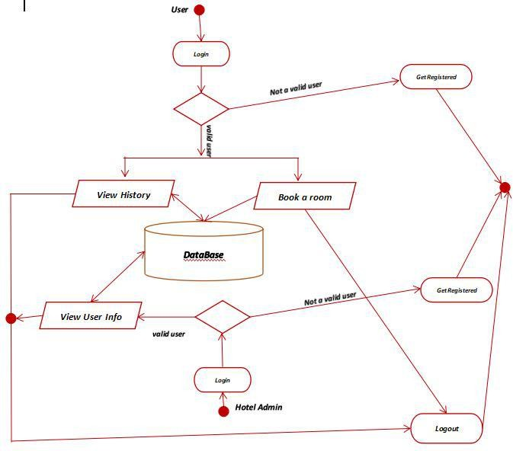

***Book a item***

***admin***

## Fig.Activity diagram

## Class Diagram:

In the software Engineering, a class diagram in the Unified Modeling Language(UML) is a type of static structure diagram that describes the structure of a system by showing the system's classes, their attributes , operations( or Methods), and the relationships among the classes. It explains which class contains information.

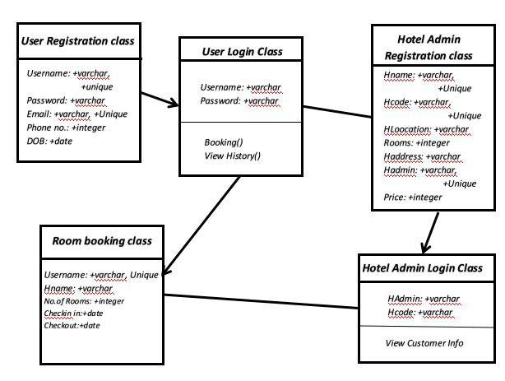

***item***

***admin***

***admin***

Fig: Class Diagram

## Data Flow Diagram

The DFD is also called as bubble chart. It is a simple graphical formalism that can be used to represent a system in terms of the input data to the system, various processing carried out on these data, and the output data is generated by the system.

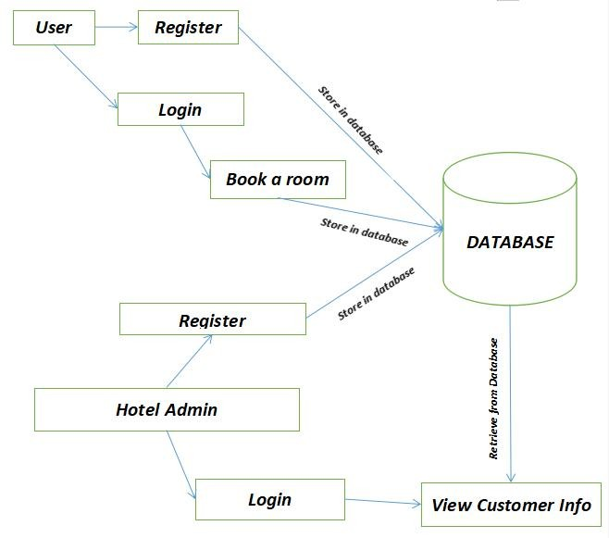

***Logout***

***Home***

***admin***

**item**

**Fig.Data flow diagram for online library**



***CHAPTER-7 CODING***

# Sample Coding:

## For checking a items Module:

**Html file:**

**<html>**

**<head>**

**<title> organic products</title>**

**<link rel="stylesheet" type="text/css" href="helo.css">**

**<link rel="stylesheet" type="text/css" href="slider.css">**

**<link rel="stylesheet" type="text/css" href="top_cat.css">**

**<link rel="stylesheet" type="text/css" href="footer.css">**

**<link rel="stylesheet" href="https://cdnjs.cloudflare.com/ajax/libs/font-awesome/4.7.0/css/font-awesome.min.css">**

**<link rel="icon" href="icon.ico" type="image/ico">**

**</head>**

**<body>**

**<!-- code for helo bar -->**

**<div id= "menu">**

**<ul>**

**<li><a href="edit.html">Home</a></li>**

**<li><a href="about.html">About</a></li>**

**<li><a href="#">Menu</a>**

**<ul>**

**<li><a href="carrot.html">carrot</a>**

**<li><a href="apple.html">apple</a>**

**<li><a href="potato.html">potato</a>**

**<li><a href="ladiesfinger">ladiesfinger</a>**

**<li><a href="strawberry.html">strawberry</a>**

**</ul></li>**

**<li><a href="order.html">Order</a></li>**

**<li><a href="contact.html">Contact</a></li>**

**</ul>**

**</div>**

**<!-- code for helo bar -->**

**<!-- code for slider -->**

**<div id="outerbox">**

**<div id="sliderbox">**

**<img src="1.jpg">**

**<img src="2.jpg">**

**<img src="3.jpg">**

**<img src="4.jpg">**

**</div>**

**</div>**

**<!-- code for slider -->**

**<br>**

**<h1 align="center">list of items</h1>**

**<br>**

**<center>**

**<!-- code for top cat -->**

**<table>**

**<td><div class="top_cat">**

**<div class="top_cat_pro"><img src="a11.jpeg" height="80%">**

**<div class="starr" >**

**<span class="fa fa-star checked"></span>**

**<span class="fa fa-star checked"></span>**

**<span class="fa fa-star checked"></span>**

**<span class="fa fa-star checked"></span>**

**<span class="fa fa-star "></span>**

**</div>**

**<div class="title">**

**<p> Straberry</p>**

**</div>**

**</div>**

**<th> <div class="top_cat_pro"><img src="a12.jpeg" height="80%">**

**<div class="starr" >**

**<span class="fa fa-star checked"></span>**

**<span class="fa fa-star checked"></span>**

**<span class="fa fa-star checked"></span>**

**<span class="fa fa-star checked"></span>**

**<span class="fa fa-star "></span>**

**</div>**

**<div class="title">**

**<p> Tomato</p>**

**</div>**

**</div><th>**

**<div class="top_cat_pro"><img src="a13.jpeg" height="80%">**

**<div class="starr" >**

**<span class="fa fa-star checked"></span>**

**<span class="fa fa-star checked"></span>**

**<span class="fa fa-star checked"></span>**

**<span class="fa fa-star checked"></span>**

**<span class="fa fa-star "></span>**

**</div>**

**<div class="title">**

**<p> Papaya</p>**

**</div>**

**</div>**

**<div>**

**</table>**

**<table>**

**<td><div class="top_cat">**

**<div class="top_cat_pro"><img src="a14.jpeg" height="80%">**

**<div class="starr" >**

**<span class="fa fa-star checked"></span>**

**<span class="fa fa-star checked"></span>**

**<span class="fa fa-star checked"></span>**

**<span class="fa fa-star checked"></span>**

**<span class="fa fa-star "></span>**

**</div>**

**<div class="title">**

**<p> Cabbage</p>**

**</div> </div>**

**<th> <div class="top_cat_pro"><img src="a15.jpeg" height="80%">**

**<div class="starr" >**

**<span class="fa fa-star checked"></span>**

**<span class="fa fa-star checked"></span>**

**<span class="fa fa-star checked"></span>**

**<span class="fa fa-star checked"></span>**

**<span class="fa fa-star "></span>**

**</div>**

**<div class="title">**

**<p> Orange</p>**

**</div></div><th>**

**<div class="top_cat_pro"><img src="a16.jpeg" height="80%">**

**<div class="starr" >**

**<span class="fa fa-star checked"></span>**

**<span class="fa fa-star checked"></span>**

**<span class="fa fa-star checked"></span>**

**<span class="fa fa-star checked"></span>**

**<span class="fa fa-star "></span>**

**</div>**

**<div class="title">**

**<p> Pomegranate</p>**

**</div> </div>**

**<div>**

**</table>**

**<!-- end code for top cat -->**

**</center>**

**<br>**

**<!-- code for footer -->**

**<div class="footer">**

**<div class="fotterb">**

**<b color="white">Quick link</b>**

**<br><br><br>**

**Home<br>**

**Menu<br>**

**Order<br>**

**Contact**

**</div>**

**<div class="fotterb">**

**<b>Menu</b>**

**<br><br>**

**carrot<br>**

**apple<br>**

**potato<br>**

**ladiesfinger<br>**

**strawberry<br>**

**</div>**

**<div class="fotterb">**

**<b>Address</b>**

**<br><br><br>**

**8-148<br>**

**Mahalakshmi veedi<br>**

**valaparla<br>**

**Martur mandel,prakasm dis<br>**

**Andhra Pradesh**

**</div>**

**<div class="fotterb">**

**<b>Direction</b>**

**<br>**

**<iframe src="https://www.google.com/maps/embed?pb=!1m18!1m12!1m3!1d15346.767310423544!2d80.0407964673425!3d15.925207857784068!2m3!1f0!2f0!3f0!3m2!1i1024!2i768!4f13.1!3m3!1m2!1s0x3a4af4d4f2c57731%3A0x6a66b62f69fd267b!2sValaparla%2C%20Andhra%20Pradesh%20523260!5e0!3m2!1sen!2sin!4v1620489476544!5m2!1sen!2sin" width="100%" height="165" style="border:0;" allowfullscreen="" loading="lazy"></iframe>**

**</div>**

**</div>**

**<!-- end code for footer -->**

**</body>**

**</html>**

## PhpFile to store data of users:

## <?php

## include("connection.php");

## error_reporting(0);

## ?>

## <html>

## <head>

## <link rel="stylesheet" href="login2.css">

## </head>

## <body>

## <form>

## <center>

## <div class="sign-div">

## <div class="logo"></div>

## <div class="title">Signup</div>

## <div class="fields">

## <div class="text1">

## <svg class="svg-icon" viewBox="0 0 20 20">

## <path d="M17.388,4.751H2.613c-0.213,0-0.389,0.175-0.389,0.389v9.72c0,0.216,0.175,0.389,0.389,0.389h14.775c0.214,0,0.389-0.173,0.389-0.389v-9.72C17.776,4.926,17.602,4.751,17.388,4.751 M16.448,5.53L10,11.984L3.552,5.53H16.448zM3.002,6.081l3.921,3.925l-3.921,3.925V6.081z M3.56,14.471l3.914-3.916l2.253,2.253c0.153,0.153,0.395,0.153,0.548,0l2.253-2.253l3.913,3.916H3.56z M16.999,13.931l-3.921-3.925l3.921-3.925V13.931z"></path>

## </svg>

## <input type="text" placeholder="username" name="firstname" required>

## </div>

## <div class="email">

## <svg class="svg-icon" viewBox="0 0 20 20">

## <path d="M17.388,4.751H2.613c-0.213,0-0.389,0.175-0.389,0.389v9.72c0,0.216,0.175,0.389,0.389,0.389h14.775c0.214,0,0.389-0.173,0.389-0.389v-9.72C17.776,4.926,17.602,4.751,17.388,4.751 M16.448,5.53L10,11.984L3.552,5.53H16.448zM3.002,6.081l3.921,3.925l-3.921,3.925V6.081z M3.56,14.471l3.914-3.916l2.253,2.253c0.153,0.153,0.395,0.153,0.548,0l2.253-2.253l3.913,3.916H3.56z M16.999,13.931l-3.921-3.925l3.921-3.925V13.931z"></path>

## </svg>

## <input type="email" placeholder="emailaddress" name="email" required>

## </div>

## <div class="password">

## <svg class="svg-icon" viewBox="0 0 20 20">

## <path d="M17.308,7.564h-1.993c0-2.929-2.385-5.314-5.314-5.314S4.686,4.635,4.686,7.564H2.693c-0.244,0-0.443,0.2-0.443,0.443v9.3c0,0.243,0.199,0.442,0.443,0.442h14.615c0.243,0,0.442-0.199,0.442-0.442v-9.3C17.75,7.764,17.551,7.564,17.308,7.564 M10,3.136c2.442,0,4.43,1.986,4.43,4.428H5.571C5.571,5.122,7.558,3.136,10,3.136 M16.865,16.864H3.136V8.45h13.729V16.864z M10,10.664c-0.854,0-1.55,0.696-1.55,1.551c0,0.699,0.467,1.292,1.107,1.485v0.95c0,0.243,0.2,0.442,0.443,0.442s0.443-0.199,0.443-0.442V13.7c0.64-0.193,1.106-0.786,1.106-1.485C11.55,11.36,10.854,10.664,10,10.664 M10,12.878c-0.366,0-0.664-0.298-0.664-0.663c0-0.366,0.298-0.665,0.664-0.665c0.365,0,0.664,0.299,0.664,0.665C10.664,12.58,10.365,12.878,10,12.878"></path>

## </svg>

## <input type="password" placeholder="password" name="password" required>

## </div>

## <div class="password2">

## <svg class="svg-icon" viewBox="0 0 20 20">

## <path d="M17.308,7.564h-1.993c0-2.929-2.385-5.314-5.314-5.314S4.686,4.635,4.686,7.564H2.693c-0.244,0-0.443,0.2-0.443,0.443v9.3c0,0.243,0.199,0.442,0.443,0.442h14.615c0.243,0,0.442-0.199,0.442-0.442v-9.3C17.75,7.764,17.551,7.564,17.308,7.564 M10,3.136c2.442,0,4.43,1.986,4.43,4.428H5.571C5.571,5.122,7.558,3.136,10,3.136 M16.865,16.864H3.136V8.45h13.729V16.864z M10,10.664c-0.854,0-1.55,0.696-1.55,1.551c0,0.699,0.467,1.292,1.107,1.485v0.95c0,0.243,0.2,0.442,0.443,0.442s0.443-0.199,0.443-0.442V13.7c0.64-0.193,1.106-0.786,1.106-1.485C11.55,11.36,10.854,10.664,10,10.664 M10,12.878c-0.366,0-0.664-0.298-0.664-0.663c0-0.366,0.298-0.665,0.664-0.665c0.365,0,0.664,0.299,0.664,0.665C10.664,12.58,10.365,12.878,10,12.878"></path>

## </svg>

## <input type="password" placeholder="conformpassword" name="conpassword" required>

## </div>

## </div>

## <input class="signin-button" type="submit" id="btn" name="submit">

## <br><br>

## already have an account?or <a href="login.php">login</a>

## </center>

## </form>

## </body>

## </html>

## <?php

## if($_GET['submit'])

## {

## $fn=$_GET['firstname'];

## $em=$_GET['email'];

## $pwd=$_GET['password'];

## $conpwd=$_GET['conpassword'];

## 

## if($fn!="" && $em!="" && $pwd!="" && $conpwd!="")

## {

## $query="INSERT INTO STUDENT1 VALUES('$fn','$em','$pwd','$conpwd')";

## $data=mysqli_query($conn,$query);

## if($data)

## {

## header('location:login.php');

## }

## }

## else

## {

## echo"fields required";

## }

## }

## ?>

## Select users from database:

## <?php

## include("connection.php");

## error_reporting(0);

## $query="SELECT *FROM STUDENT1";

## $data=mysqli_query($conn,$query);

## $total=mysqli_num_rows($data);

## if($total!=0)

## {

## while($result=mysqli_fetch_assoc($data))

## {

## echo $result['rollno']."".$result['firstname']."".$result['lastname']."".$result['email']."".$result['password']."".$result['conpassword']."<br/>";

## }

## }

## else

## {

## echo"does not have records";

## }

## ?>



***CHAPTER-8 TESTING***

## TESTING

The purpose of testing is to discover errors. Testing is the process of trying to discover every conceivable fault or weakness in a work product. It provides a way to check the functionality of components, sub-assemblies, assemblies and/or a finished product It is the process of exercising software with the intent of ensuring that the

Software system meets its requirements and user expectations and does not fail in an unacceptable manner. There are various types of test. Each test type addresses a specific testing requirement.

### TYPES OF TESTS

***Unit Testing***

Unit testing involves the design of test cases that validate that the internal program logic is functioning properly, and that program inputs produce valid outputs. All decision branches and internal code flow should be validated. It is the testing of individual software units of the application .it is done after the completion of an individual unit before integration. This is a structural testing, that relies on knowledge of its construction and is invasive. Unit tests perform basic tests at component level and test a specific business process, application, and/or system configuration. Unit tests ensure that each unique path of a business process performs accurately to the documented specifications and contains clearly defined inputs and expected results.

## Integration Testing

Integration tests are designed to test integrated software components to determine if they actually run as one program. Testing is event driven and is more concerned with the basic outcome of screens or fields. Integration tests demonstrate that although the components were individually satisfaction, as shown by successfully unit testing, the combination of components is correct and consistent. Integration testing is specifically aimed at exposing the problems that arise from the combination of components.

### Functional Test

Functional tests provide systematic demonstrations that functions tested are available as specified by the business and technical requirements, system documentation, and user manuals.Functional testing is centered on the following items:

Valid Input : identified classes of valid input must be accepted. Invalid Input : identified classes of invalid input must be rejected. Functions : identified functions must be exercised.

Output : identified classes of application outputs must be exercised. Systems/Procedures: interfacing systems or procedures must be invoked.

Organization and preparation of functional tests is focused on requirements, key functions, or special test cases. In addition, systematic coverage pertaining to identify Business process flows; data fields, predefined processes, and successive processes must be considered for testing. Before functional testing is complete, additional tests are identified and the effective value of current tests is determined.

### System Test

System testing ensures that the entire integrated software system meets requirements. It tests a configuration to ensure known and predictable results. An example of system testing is the configuration oriented system integration test. System testing is based on process descriptions and flows, emphasizing pre-driven process links and integration points.

### White Box Testing

White Box Testing is a testing in which in which the software tester has knowledge of the inner workings, structure and language of the software, or at least its purpose. It is purpose. It is used to test areas that cannot be reached from a black box level.

### Black Box Testing

Black Box Testing is testing the software without any knowledge of the inner workings, structure or language of the module being tested. Black box tests, as most other kinds of tests, must be written from a definitive source document, such as specification or requirements document, such as specification or requirements document. It is a testing in

which the software under test is treated, as a black box .you cannot “see” into it. The test provides inputs and responds to outputs without considering how the software works.

## Unit Testing:

Unit testing is usually conducted as part of a combined code and unit test phase of the software lifecycle, although it is not uncommon for coding and unit testing to be conducted as two distinct phases.

## Test strategy and approach

Field testing will be performed manually and functional tests will be written in detail.

## Test objectives

* + - All user views must work properly.
    - The distance and values should be clearly visible.
    - There toast messages should be able to help the user understand the problem.

## Features to be tested

* + - Verify that the distance and signal states are accurate.
    - The coordinates checking must be then at periodic time intervals.
    - The Bluetooth device list page should be able connect the application to the chosen Bluetooth module.

## Integration Testing

Software integration testing is the incremental integration testing of two or more integrated software components on a single platform to produce failures caused by interface defects.

The task of the integration test is to check that components or software applications, e.g. components in a software system or – one step up – software applications at the company level – interact without error.

**Test Results:** All the test cases mentioned above passed successfully. No defects encountered.

## Acceptance Testing

User Acceptance Testing is a critical phase of any project and requires significant participation by the end user. It also ensures that the system meets the functional requirements.

**Test Results:** All the test cases mentioned above passed successfully. No defects encountered.



***CHAPTER-9 SCREENSHOTS***

## 9. SCREENSHOTS

1. **Home page**

## Fig: Home page

1. **User Registration**

## Fig: Registration Page For User

1. **User login**

## Fig: User Login page

1. **About**

## Fig: About page

1. **Menu**

**Fig: Menu Page**

## Order page:

**Fig: Order Page**

## Admin Contact page:

**Fig: admin contact Page**



***CHAPTER-10***

***CONCLUSION***

## CONCLUSION

* By developing this application we can contain some preservative that makes the food fresh for longer time and it is also free from all the chemicals. The organic agriculture is also good for the environment.

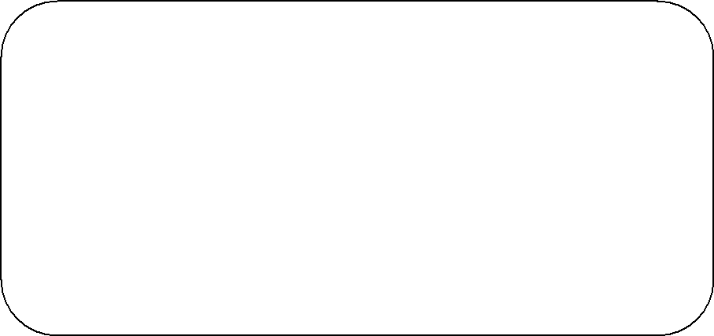

***CHAPTER-11 FUTURE ENHANCEMENT***

## FUTURE ENHANCEMENT

As the technology changes or new requirements are expected by the user, to enhance the functionality of the product may require new versions to be introduced. Although the system is complete and working efficiently, new changes which enhance the system functionality can be added without any major changes to the entire system. But we mainly made this project to save users time. So as to make agro agency work more easier by adding their other facilities like food, gaming and other bookings also to the system and help them in reaching the users for these services.



***CHAPTER-12 BIBLIOGRAPHY***

## BIBLIOGRAPHY

1. **Chhabra, R., Kolli, S., & Bauer, J. H. (2013) Organically Grown Food Provides Health Benefits to Drosophila Melanogaster. PLoS One, 8(1). doi: 10.1371/journal.pone.0052988**
2. **Crinnion, W. J. (2010). Organic Foods Contain Higher Levels of Certain Nutrients, Lower Levels of Pesticides, and May Provide Health Benefits for the Consumer. Alternative Medicine Review, 15(1), 4-12.**
3. **Gasson, M. (2001). Scientific perspectives on regulating the safety of genetically modified foods. NATURE REVIEWS GENETICS, 2(3), 217.**
4. **Huber , M., Bakker, M., Dijk, W., Prins, H., & Wiegant, F. (2012). The challenge of evaluating health effects of organic food; operationalisation of a dynamic concept of health . Journal of the Science of Food and Agriculture, 92(14), 2766-2773. doi: 10.1002/jsfa.5563**
5. **Jardine, C., Hrudey. S., Shortreed J., Craig, L., Krewski, D., Frugal C., & McColl S. (2003). Risk Management Frameworks for Human and Environmental Risks. J Toxicol Environ Health B Crit Rev, 6(6), 569-720.**